**SQL Queries for Pizza Project**

1 For KPI

## Total_revenue   
select sum(total_price) as Total_Revenue from pizza_sales

## Average_Order_value

Select sum(total_price) / Count(distinct order_id) as Avg_Order_Value from pizza_sales

## Total_pizza_sold  
Select sum(quantity) as Total_Pizza_sold from pizza_sales

//Total_orders

select (count (distinct order_id)) as Total_Orders from pizza_sales

//Average_Pizza_sold_per_order

select Cast(cast(sum(quantity) as decimal(10,2)) / cast(Count(distinct order_id) as decimal(10,2)) as decimal(10,2)) as Average_Pizza_sold_per_order from pizza_sales



--CHART--

--Daily Trend--

select datename(DW, order_date) as Order_day , count(distinct order_id) as Total_orders from pizza_sales

group by datename(DW, order_date)

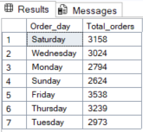

--Hourly Trend--

select datepart(hour , order_time) as Order_hour, count(distinct order_id) as Total_orders from pizza_sales

group by datepart(hour , order_time)

order by datepart(hour , order_time)

--Percentage Of sales by category--

select pizza_category ,sum(total_price) as Total_sales_Price_category, sum(total_price)*100 / (select sum(total_price) from pizza_sales) as Total_Percentage_sales

from pizza_sales

group by pizza_category

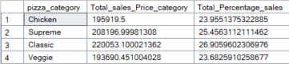

--Percentage Of sales by category--

select pizza_size ,cast(sum(total_price)as decimal(10,2)) as Total_sales_Price_category, cast(sum(total_price)*100 as decimal(10,2)) / (select cast(sum(total_price)as decimal(10,2)) from pizza_sales) as Total_Percentage_sales

from pizza_sales

group by pizza_size

order by Total_Percentage_sales asc

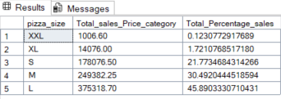

--Total Pizza Sold--

select pizza_category, sum(quantity) as Total_pizzas_sold from pizza_sales

group by pizza_category

--Top 5 worst sellers WRT pizza sold --

select top 5 pizza_name, sum(quantity) as Total_pizzas_sold from pizza_sales

group by pizza_name

order by sum(quantity) asc

--Top 5 best sellers WRT pizza sold --

select top 5 pizza_name, sum(quantity) as Total_pizzas_sold from pizza_sales

group by pizza_name

order by sum(quantity) desc

